
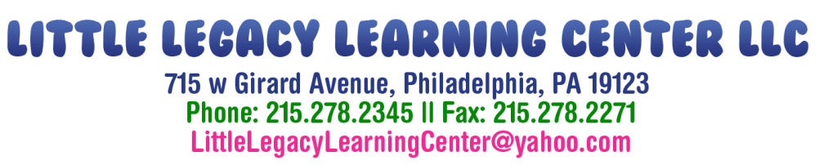

Photo Release Form
Provider’s Name: Little Legacy Learning Center
Child’s Full Name: ___________________________________
Photographs and videos are taken on different occasions such as birthdays, holidays, outings, and special occasions. We use these pictures/videos in our child care center for things such as teaching, arts & crafts, and advertising.
Please mark the appropriate box:
I give permission I do not give permission
to Little Legacy Learning Center to take photographs or have photographs taken of the above child should the occasion arise.
Please mark the appropriate box:
I give permission I do not give permission
to Little Legacy Learning Center to take videos or have videos taken of the above child should the occasion arise.

I understand that these photographs and/or videos will not be sold or distributed, but may be placed on the company’s website and social outlets for advertising purposes.

Parent/Guardian Signature _________________________ Date ____________

Management Staff Signature _______________________ Date ____________

