

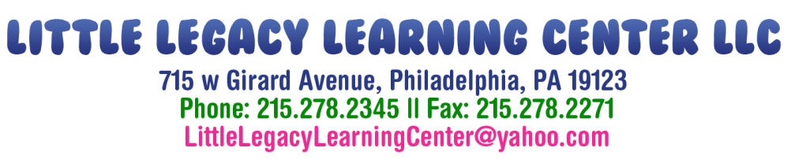

What to Bring on Your First of School

Infants and Toddlers

- Bring your child 2 full sets of clothing, including socks
- Diapers and wipes
- At least 3 clean bottles (for infants)
- Sippy cup (for toddlers)
- A sheet and blanket for naptime

Preschool

- Bring your child 2 full sets of clothing, including underwear and socks
- A sheet and blanket for naptime
- A plastic storage box, with wipes, tissues and other items to help your child be fresh and clean during the day

After School/Summer Camp

- Bring your child 2 full sets of clothing, including underwear and socks
- Plastic zip lock bag with wipes, tissues and other toiletries to help your child be fresh and clean during the day
- Backpack for carrying their items

We are not responsible for lost or stolen items, therefore –
PLEASE LABEL ALL OF YOUR CHILD’S ITEMS WITH A
PERMANENT MARKER!
